2nd Industrial Revolution Project

For this project, each of you will be assigned a name of a nineteenth century industrialist or a person who had a significant impact within the 2nd Industrial Revolution. You will create an informational document/brochure which contains the format outlined below:

1) Biography: a concise five paragraph biographical section about your assigned person. This should include where they are born, their upbringing, what they accomplished during the Industrial Revolution, how they died, and what their legacy consists of.

2) Facts: a list of five interesting facts about your assigned person

3) Pictures: Your document should have at least 3 pictures (be sure to cite the pictures)

4) Works Cited: Works cited needs to be in appropriate MLA format and should contain AT LEAST 5 reliable sources (not including pictures) – no Wikipedia or other untrustworthy online sources.

Grading: The rubric, included on the next page, will be used to grade your project. The project counts as a test grade. The following marks indicate the following scores:

20: 100% 10: 50%

19: 95% 9: 45%

18: 90% 8: 40%

17: 85% 7: 35%

16: 80% 6: 30%

15: 75% 5: 25%

14: 70% 4: 20%

13: 65% 3: 15%

12: 60% 2: 10%

11: 55% 1: 5%

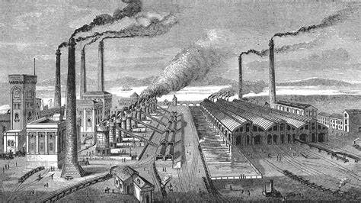

***Assigned Industrialists***

***2nd Period***

Zamil – James Fisk

Jacob – William Randolph Hearst

Farzeen – Hiram Percy Maxim

Tyler – Cornelius Vanderbilt

Joshua – Alvah C. Roebuck

Angelina – Richard Jordan Gatling

Ryan I.– John W. Wyatt

Islande – Samuel Gompers

Rhegan – George Westinghouse

Bobby – Jason Gould

Olivier – James Bailey

Chandler – Richard Warren Sears

Eduardo – Guglielmo Marconi

Reylee – Mark Twain

Sophia M. – James Buchanan Eads

Shelley – Harvey Firestone

Sophia P. – Terrence Powderly

Aarya – The Wright Brothers

Kathryn – Elisha Otis

Daniel – George Washington Carver

Luke – Charles Goodyear

Christopher – Henry A. Strong

Ryan R. – John Rockefeller

James – Henry Flagler

Kenasia – Henry Bessemer

Ethan – Charles Pratt

***5th Period***

Madison – Joseph Pulitzer

Nadia – Andrew Carnegie

Gabriella – James Buchanan Duke

Sterling – John Deere

Sara – Henry Ford

Christian – Thomas Edison

Sonaya – Andrew Mellon

Jaclyn – George Eastman

Arianna – J.C. Penney

Daniela – Henry C. Frick

Jordan – Alexander Graham Bell

Annarose – P.T. Barnum

Ian – Gustavus Swift

Dieuvelt – George Pullman

Kate – Henry Adams

Carley – Isaac Singer

Ephraim – J.P. Morgan

Anna – Nikola Tesla

Roseanne – Alvah Curtis Roebuck

Liana – Jacob Riis

Bianca – Joseph Glidden

Christina - John Gorrie

