IB History
Course Syllabus
Instructor: Dr. Sielinski
Classroom: #251
Phone: (772) 468-5474 ext. 7605
Email: brent.sielinski@stlucieschools.org
Website: http://www.drsielinski.com
The Diploma Program
The Diploma Program (DP) is a rigorous pre-university program designed for students in the 16 to 19 age range. It is a broad-based two-year program that aims to encourage students to be knowledgeable and inquiring, but also caring and compassionate. There is a strong emphasis on encouraging students to develop intercultural understanding, open-mindedness, and the attitudes necessary for them to respect and evaluate a range of points of view.

The Nature of the Subject
History is a dynamic, contested, evidence-based discipline that involves an exciting engagement with the past. It is a rigorous intellectual discipline, focused around key historical concepts such as change, causation and significance.

History is an exploratory subject that fosters a sense of inquiry. It is also an interpretive discipline, allowing opportunity for engagement with multiple perspectives and a plurality of opinions. Studying history develops an understanding of the past, which leads to a deeper understanding of the nature of humans and of the world today.
The IB Diploma Programme (DP) history course is a world history course based on a comparative and multi-perspective approach to history. It involves the study of a variety of types of history, including political, economic, social and cultural, and provides a balance of structure and flexibility. The course emphasizes the importance of encouraging students to think historically and to develop historical skills as well as gaining factual knowledge. It puts a premium on developing the skills of critical thinking, and on developing an understanding of multiple interpretations of history. In this way, the course involves a challenging and demanding critical exploration of the past.
History Aims

The aims of the IB History (HL) course are to:
1. develop an understanding of, and continuing interest in, the past
2. encourage students to engage with multiple perspectives and to appreciate the complex nature of historical concepts, issues, events and developments
3. promote international-mindedness through the study of history from more than one region of the world
4. develop an understanding of history as a discipline and to develop historical consciousness including a sense of chronology and context, and an understanding of different historical perspectives
5. develop key historical skills, including engaging effectively with sources
6. increase students’ understanding of themselves and of contemporary society by encouraging reflection on the past.

Instructional Text: The following textbooks and monographs will be used in the course:

11th Grade:
Kennedy, David M., Cohen, Lizabeth, and Bailey, Thomas A. The American Pageant: A History of the Republic. Boston: Wadsworth Publishing Company, 1998.
ISBN Number: 0669397288

Leppard, Thomas, Berliner, Yvonne, Mamaux, Alexis, Rogers, Mark, and Smith, David. IB History of the Americas Course Book. Oxford: Oxford University Press, 2012.
ISBN Number: 0198390157

12th Grade:

Rogers, Keely, and Thomas, Jo. The Move to Global War. Oxford: Oxford University Press, 2014.
ISBN Number: 0198310188

Suchlicki, Jamie. Cuba: From Columbus to Castro and Beyond. Lincoln: Potomac Books, 2002.
ISBN Number: 1574884360

Tomkinson, John. Themes in 20th Century World History for the International Baccalaureate. Athens: Anagnosis Publishing, 2008.
ISBN Number: 960880874X

11th Grade Prescribed Subjects:

Year One of IB History will cover the following prescribed subjects, necessary to pass Paper 3 (HL Paper – worth 35% of the total IB History grade) of the IB exam, taken in May of senior year. Students will also have the option to answer questions on the IB exam pertaining to prescribed subjects relating to material covered during ninth-grade AP U.S. Government and tenth-grade AP World History.

United States’ Civil War: Causes, course and effects (1840–1877) This section focuses on the United States’ Civil War between the North and the South (1861–1865), which is often perceived as the great watershed in the history of the United States. It transformed the country forever, but the war created a new set of problems: how would the country be reunited? How would the South rebuild its society and economy? How would the four million freed former slaves fit into society?
The development of modern nations (1865–1929) This section, covering the period between the late 19th century and the early 20th century, saw forces that transformed the countries of the region. These forces are generally seen as part of “modernization”, a process that involved the progressive transformation of the economic, political and social structures of the countries of the region. With respect to the first four bullets, a case-study approach should be adopted, using two countries from the region as examples.
Emergence of the Americas in global affairs (1880–1929) This section focuses on the impact of modernization in the region on foreign policy, including an exploration of the involvement of the region in the First World War. Modernization shaped the new nations, and its effects created the basis for a major shift in the foreign policies of the region. By the end of the 19th century, for example, the United States played a more active role in world affairs and in the affairs of Latin America in particular, thus transforming inter-American relations. When the First World War ended, its impact was felt in the economic, social and foreign policies of the participating countries.
The Great Depression and the Americas (mid 1920s–1939) This section focuses on the causes and nature of the Great Depression as well as the different solutions adopted by governments in the region, and the impact on these societies. The Great Depression produced the most serious economic collapse in the history of the Americas. It affected every country in the region and brought about the need to rethink economic and political systems. The alternatives that were offered, and the adaptations that took place, marked a watershed in political and economic development in many countries in the region. With respect to the last three bullets, a case-study approach should be adopted, using one country from the region as an example. The chosen country should be identified in the introduction to the examination answers.
The Second World War and the Americas (1933–1945) As the world order deteriorated in the late 1930s, resulting in the outbreak of war in Europe and Asia, the countries of the region reacted in different ways to the challenges presented. This section focuses on the changing policies of the countries in the region as a result of growing political and diplomatic tensions prior to, and during, the Second World War. It also examines the impact of the war upon the Americas.
Political developments in the United States (1945–1980) and Canada (1945–1982) This section explores the domestic concerns and political developments in the United States and Canada, with a specific focus on the domestic policies and achievements of particular leaders in each country. In the United States, there is also a focus on economic development and the changing composition of the main political parties. In Canada, there is an exploration of the separatism of the Quiet Revolution.
The Cold War and the Americas (1945–1981) This section focuses on the development and impact of the Cold War on the region. Most of the second half of the 20th century was dominated by the global conflict of the Cold War. Within the Americas, some countries were closely allied to the United States and some took sides reluctantly. Many remained neutral or sought to avoid involvement in Cold War struggles. A few, influenced by the Cuban Revolution, instituted socialist governments. No nation, however, escaped the pressures of the Cold War, which had a significant impact on the domestic and foreign policies of the countries of the region.
The Americas (1980–2005) This section focuses on changing trends in foreign and domestic policies in the Americas. In the latter decades of the 20th century, the region experienced significant political, social, cultural and economic changes. The section also considers the transitions to democracy in Latin America and the challenges encountered.

12th Grade Prescribed Subjects:

Year Two of IB History will cover the following prescribed subjects, and will encompass Paper 1 and Paper 2.
Paper 1 - Case Study 1: Japanese expansion in East Asia (1931-1941)
Causes of Expansion
*The impact of Japanese nationalism and militarism on foreign policy
*Japanese domestic issues: political and economic issues, and their impact on foreign relations
*Political instability in China
Events
*Japanese invasion of Manchuria and northern China (1931)
*Sino-Japanese War (1937-1941)
*The Three-Power/Tripartite Pact; the outbreak of war; Pearl Harbor (1941)
Responses
*League of Nations and the Lytton Report
*Political developments within China - the Second United Front
*International response including US initiatives and increasing tensions between the U.S. and Japan

Paper 1 - Case Study 2: German and Italian Expansion (1933-1940)
Causes of Expansion
*Impact of fascism and Nazism on the foreign policies of Italy and Germany
*Impact of domestic economic issues on the foreign policies of Italy and Germany
*Changing diplomatic alignments in Europe; the end of collective security; appeasement
Events
*German challenges to the post-war settlements (1933-1938)
*Italian expansion: Abyssinia (1935-1936); Albania; entry into the Second World War
*German expansion (1938-1939); Pact of Steel, Nazi-Soviet Pact and the outbreak of war
Responses
*International response to German aggression (1933-1938)
*International response to Italian aggression (1935-1936)
*International response to German and Italian aggression (1940)

Paper 2

Cause and Effects of 20th Century Wars
This topic focuses on the causes, practice and effects of war in the 20th century. The topic explores the causes of wars, as well as the way in which warfare was conducted, including types of war, the use of technology, and the impact these factors had upon the outcome. Examination questions for this topic will require students to make reference to specific 20th-century wars in their responses, and some examination questions will require discussion of wars from more than one region of the world. Please note that the suggested examples for this topic include “cross-regional” wars such as the First and Second World Wars. In examination questions that ask students to discuss examples of wars from different regions, students may use these wars in a regional context (for example, the Second World War in the Pacific) but may not then use the same war in a different region (for example, the Second World War in Europe) in the same response.
Authoritarian States
This topic focuses on exploring the conditions that facilitated the rise of authoritarian states in the 20th century, as well as the methods used by parties and leaders to take and maintain power. The topic explores the emergence, consolidation and maintenance of power, including the impact of the leaders’ policies, both domestic and foreign, upon the maintenance of power. Examination questions for this topic will expect students to make reference to specific authoritarian states in their responses, and some examination questions will require discussion of states from more than one region of the world. In order for students to be able to make meaningful comparisons across all aspects of the prescribed content, it is recommended that a minimum of three authoritarian states should be studied.

The Cold War
The Cold War dominated global affairs from the end of the Second World War to the early 1990s. This topic focuses on how superpower rivalries did not remain static but changed according to styles of leadership, strength of ideological beliefs, economic factors and crises involving client states. The topic aims to promote an international perspective on the Cold War by requiring the study of Cold War leaders, countries and crises from more than one region of the world.

Internal Assessment
Students are required to complete a historical investigation into a topic of their choice. It is worth 20% of their final IB History grade. The historical investigation is made of up three sections, as seen in the illustration below. Students have a free choice of topic for this historical investigation and are encouraged to use their own initiative when deciding on a topic. However, the topic must be historical, and cannot be on an event that has happened in the last 10 years. The internal assessment requires that students elect, evaluate and use evidence to reach a relevant historical conclusion consistent with arguments that have been put forward. The internal assessment cannot exceed 2,200 words and will take place during the Spring semester of Junior year and the Fall semester of senior year.
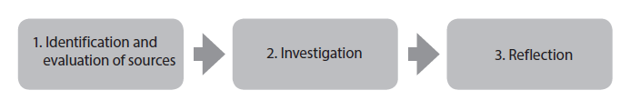
Classroom Website
The classroom website can be accessed by typing http://www.drsielinski.com or from clicking the link off the IB tab on Lincoln Park Academy’s school website. The classroom website contains weekly agendas, assignments, PowerPoints, and other information important for scholarly engagement. It also contains more details about the Prescribed Subjects and what students need to know to be prepared to excel on their internal assessment, as well as the IB History exam during May their senior year.
Academic Dishonesty
Any dishonest way of obtaining or distributing information could result in a zero for the assignment. Academic dishonesty is not only ethically wrong and unfair to students who work/study legitimately, but prevents you from learning the information. The Merriam-Webster dictionary defines plagiarism as: an act or instance of using or closely imitating the language and thoughts of another author without authorization and the representation of that author's work as one's own, as by not crediting the original author. When in doubt, CITE YOUR SOURCES. All rules and procedures from the Student Handbook and Code of Conduct will be followed.
Grade Distribution
Tests/Projects | 50%
Quizzes | 30%
Classwork | 10%
Homework | 10%
Classroom Guidelines and Procedures:
- Be to class on time and ready to learn – Upon entrance into the classroom, you should have your preferred note-taking method, either notebook or laptop, ready. You should be prepared to learn about the objective at hand for the day. You should be attentive during class and only be working on materials needed for this class. (See laptop policy)
- If you are not in your assigned seat when the bell rings, you will be marked tardy.
- Permission to leave class will not be granted unless you have your own planner.
- No food, drinks, or gum are allowed in class.
- Please stay in your seat, be attentive, and focus on coursework. Keep your head up and work hard to focus during class. Make sure your area is cleaned up before leaving at the end of class. Do not write on any tables or laptops.
- If you are absent it is your responsibility to check with the teacher for any missed assignments or go to www.drsielinski.com to find out what work was missed. The guidelines set forth in your Student Handbook will be followed.
- Electronic devices are allowed to be carried on campus but must be concealed and on silent, or turned off. Devices can be confiscated if these rules are violated.
- Put your best effort forward – Always strive to do your best and you will excel in this class. Do not be afraid to ask any questions related to this course you may have. No question is a stupid question. Discussion and participation is a must!
- Respect – No inappropriate behavior of any kind is acceptable. The school discipline code of conduct will be enforced.

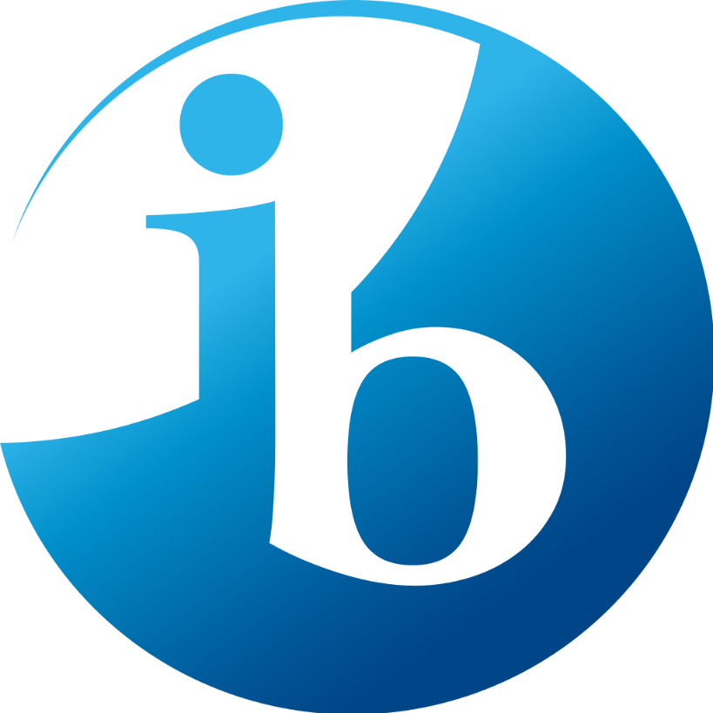

IB History Laptop Usage Policies
(Source: St. Lucie County Schools Student Code of Conduct)
Overview
The School District provides its students access to a multitude of technology resources to enhance and extend the learning experience. These resources provide opportunities to enhance learning and improve communication within our community and with the global community beyond our campus. The advantages of having access to these resources are far greater than any potential downside. However, with the privilege of access is the responsibility of students to exercise appropriate personal responsibility in their use of these resources. This School District policy is intended to promote the most effective, safe, productive, and instructionally sound uses of networked information and communication tools. The School District also makes a good faith effort to protect its students from exposure to internet materials that are harmful or explicit. The School District maintains a system of internet content filtering devices and software controls to block obscene and pornographic materials and materials that are harmful to, or otherwise inappropriate for, minors that meet federal standards established in the Children’s Internet Protection Act, 47 U.S.C. § 254(h), (1), as amended (CIPA). Nevertheless, it is impossible to control all materials available on the internet, and users will be responsible for ensuring that their use meets the requirements established in this Policy.
Digital Citizen
Student users of the School District’s computer, network, and internet resources shall use information and technology in safe, legal, and responsible ways. A responsible digital citizen is one who:
1. Respects One's Self: Users will select online names that are appropriate and will consider the information and images that are posted online.
2. Respects Others: Users will refrain from using technologies to bully, tease or harass other people.
3. Protects One's Self and Others: Users will protect themselves and others by reporting abuse and not forwarding inappropriate materials or communications.
4. Respects Intellectual Property: Users will cite any and all use of websites, books, media, etc.
5. Protects Intellectual Property: Users will request to use the software and media others produce.

Expectations
Responsible use of the School District's technology resources is expected to be ethical, respectful, academically honest, and supportive of the School District’s mission. Each computer user has the responsibility to respect every other person in our community and on the internet. Students shall receive training regarding appropriate online behavior, including interacting with other individuals on social networking Web sites and in chat rooms and cyberbullying awareness and response. Digital storage and electronic devices used for school purposes will be treated as extensions of the physical school space. Administrators, or their designees, will periodically monitor the online activities of users and computer files to ensure that users are using the system in accordance with School District policy. No user of the School District’s networks shall have an expectation of privacy when using the network. Users should not expect that electronic communications made or received on School District networks, internet searches on School District networks, or files stored on servers or disks will be private. Users also should understand that internet activity is recorded in log files. Users are expected to abide by the generally accepted rules of network etiquette. The following Policy is intended to clarify expectations for conduct, but they should not be construed as all-inclusive.

1. Use of electronic devices should be consistent with the School District's educational objectives, mission and curriculum.
2. Inappropriate use includes, but is not limited to: (1) activation, display, use, manipulation, or inappropriate storage during prohibited times; (2) texting, phoning, or web browsing during prohibited times; (3) taping conversations, music, or other audio at any time; (4 ) photography or videography of any kind; and (5) any activity that could in any manner infringe upon the rights of other individuals, including but not limited to students, teachers, and staff members.
3. Transmission of any material in violation of any local, federal and state laws is prohibited. This includes, but is not limited to, copyrighted material, licensed material and threatening or obscene material.
4. Intentional or unintentional use of computing resources to access or process, proxy sites, pornographic material, explicit text or files, or files dangerous to the integrity of the network is strictly prohibited.
5. Software or services may not be installed or downloaded on school devices without prior approval of the School District.
6. Any malicious attempt to harm or destroy data of another user, the internet or other networks, is strictly prohibited. This includes, but is not limited to, creating or uploading computer viruses.
7. Unauthorized access to information by unauthorized recipients or “hacking” is strictly prohibited. This would include intentionally bypassing any internet filtering devices.
8. Use of electronic devices to bully or harass, as defined in Policy 3.43 included in Appendix A, is strictly prohibited.
9. Student internet interpersonal communications (e.g., chat room, instant messaging, blogging, Wiki) requires authorization of a teacher or school administrator.
10. Users may be held personally and financially responsible for malicious or intentional damage done to network software, data, user accounts, hardware or unauthorized costs incurred.
11. Files stored on School District-managed networks are the property of the School District and, as such, may be inspected at any time and should not be considered private.
12. Materials published for electronic publication must be for educational purposes. School administrators, teachers and staff may monitor these materials to ensure compliance with content
13. Users who accidentally access inappropriate materials or witness another user accessing inappropriate materials, shall immediately notify their teacher or school administrator.

Policy Violations
Violating any portion of this Policy may result in disciplinary action as provided in this Code. A student may be disciplined under the Code for expressive off-campus conduct (such as e-mails or postings on social media like Facebook, YouTube, Twitter, blogs, etc.) where: (1) such conduct would foreseeably create a risk of material and substantial disruptions within the school environment; (2) it was reasonably foreseeable that the off-campus expression might reach campus; and (3) the conduct did create a material and substantial disruption within the school environment. Disciplinary action shall be proportional to the offense. The School District will cooperate with law enforcement officers in investigations related to illegal activities conducted through its network. Some violations may constitute criminal offenses and may result in criminal prosecution.

Other Expectations:

1. Laptops are only to be used when permitted by teacher – usage during improper times or using the laptops for purposes other than what was instructed may result in loss of laptop privileges and/or referrals.
2. Do NOT cause any intentional damage to the laptops – this includes but is not limited to: drawing on laptops, taking keys off the key board, and slamming laptops closed.

By signing I agree - I have read and understand the 2021-2022 IB History Syllabus/Laptop Usage Policies. I am aware if there are any questions, I should contact Dr. Sielinski.
Student Printed Name: _______________________________________________
Student Signature: __________________________________________________

Parent/Guardian Printed Name: _________________________________________
Parent/Guardian Signature: ____________________________________________

Parent/Guardian Contact Information: ____________________________
_____________________________
_____________________________
_____________________________
