History IA Final Checklist
Please go over the checklist below to ensure you have everything completed before emailing me your final IA. There is an example of a cover page and table of contents included below as well.

- Footnote number comes at the end of the sentence, including the period _____
- There are no floating quotes, meaning sentences don’t start
and end with quotation marks _____

- There are AT LEAST 3-4 citations on every page of Section 2 _____
- I used AT LEAST 10 sources throughout my paper _____
- Section 1 content value/limitations include specific references from the text _____

- Section 2 includes various perspectives, including those from historians _____
- Section 3 provides connections to the investigation _____
- The paper is in 12-font, Times New Roman, Double-Spaced _____
- Footnotes are in 10-font, Times New Roman _____
- I included a cover page, table of contents, and bibliography _____
- There are page numbers in the upper right corner starting at Section 1. _____
There should be no page numbers on the title page and the table of contents.
There is no last name before the page number.

- The final paper is in .pdf format, with no identifying information except for _____
the file name which should be lastname.firstname

- There is a smile on my face because the first major assignment of the
2021-2022 school year is done! _____

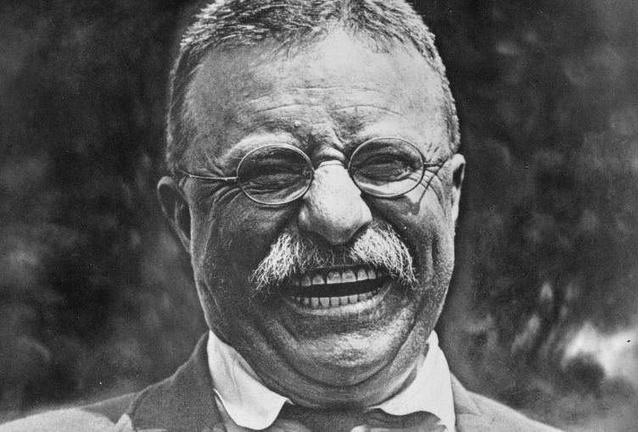

To what extent did the Federal Military Government of Nigeria under the leadership of Yakubu Gowon commit genocide during Nigeria-Biafra War of 1967-1970?

History Internal Assessment
Word Count: 2,200

Table of Contents

Section 1: Identification and Evaluation of Sources................................................................1-2

Section 2: Investigation............................................................................................................3-6

Section 3: Reflection.................................................................................................................7

Bibliography..............................................................................................................................8-9

