Read pages 14-24 in The Move to Global War and complete the following activities on a separate piece of paper. Read the directions for each activity carefully and make sure you answer the questions in the amount of sentences noted for each. Feel free to write more than the minimum suggested sentences.
Activity #1 (1 Question; answer in at least two sentences)
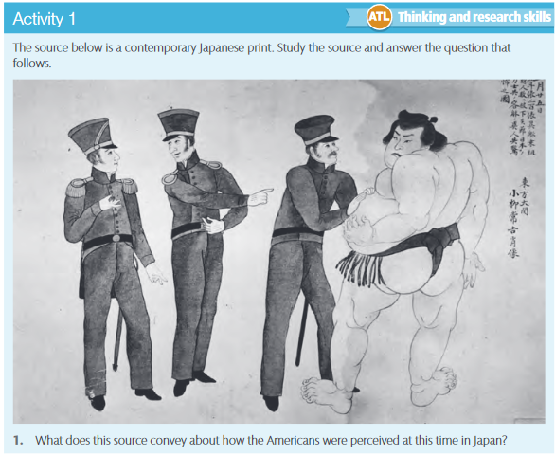

Activity #2 (2 Questions; answer each question in at least two sentences)
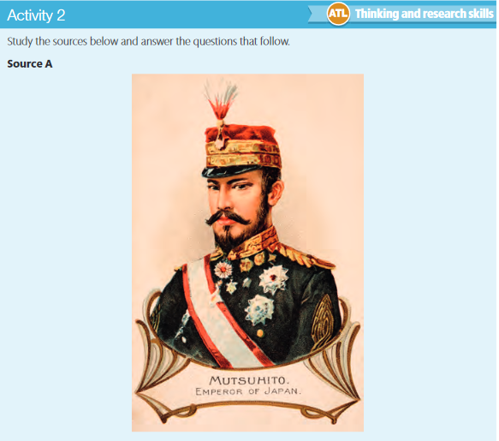
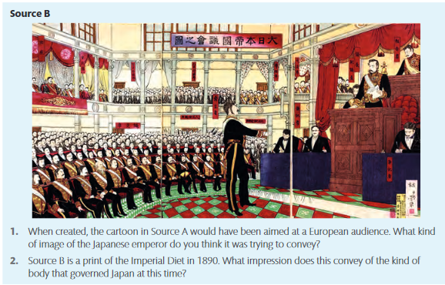
Activity #3 (1 Question; answer each part in at least one sentence - total of two sentences)
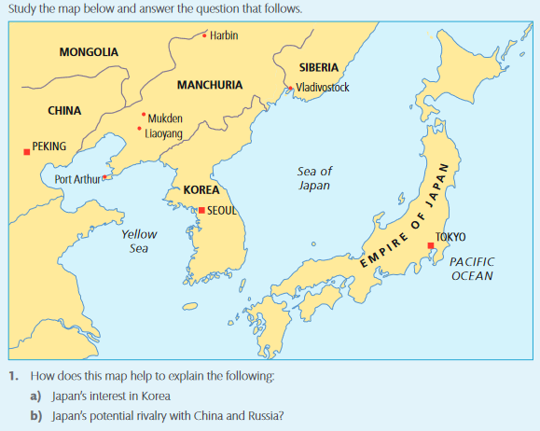

Activity #4 (1 Question; answer in at least three sentences)
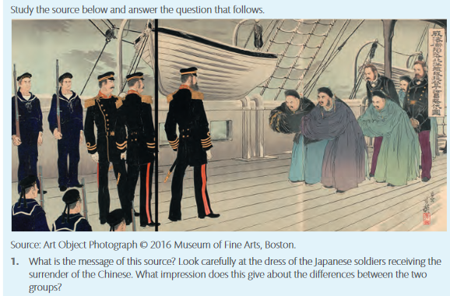
Activity #5 (3 Questions; at least two sentences per question – total of six sentences)

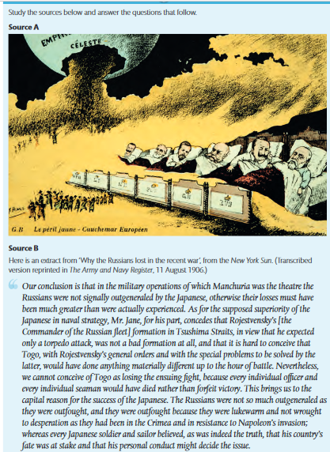
Activity #5 (continued)
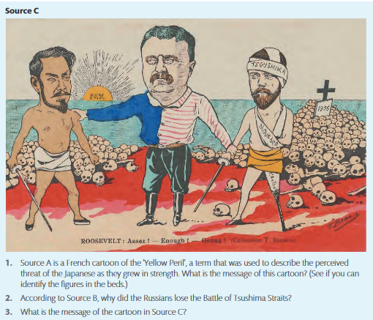
Activity #6
Define the following terms in at least one complete sentence per term.
Nationalism
Militarism
Shogun
Commodore Matthew Perry
Sino-Japanese War
Treaty of Shimonoseki
Triple Intervention
Russo-Japanese War
Treaty of Portsmouth

